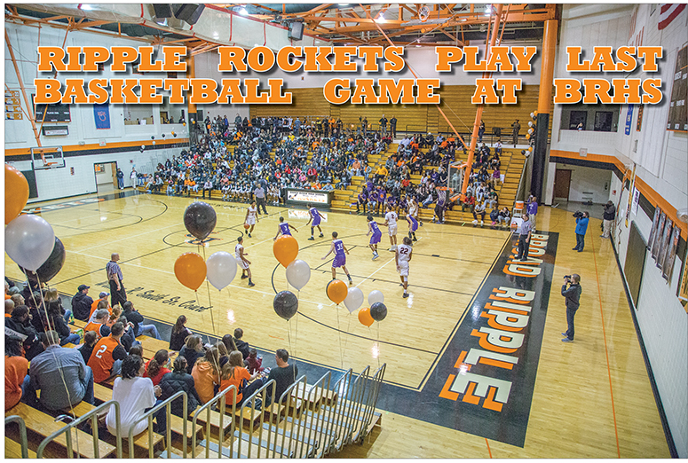
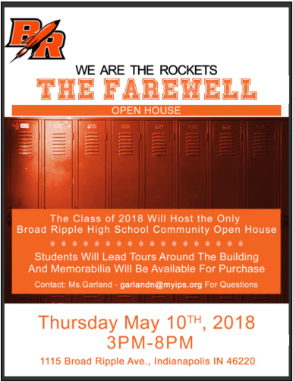
BROAD RIPPLE HIGH SCHOOL
CLASS OF 1956
HOMECOMING FOR THE LAST TIME!!!
LET'S GET TOGETHER FOR A MINI-REUNION
AND A LAST CHANCE TO VISIT OUR OLD SCHOOL

Put Thursday, May 10th on your calendar to join the Class of 56 for a buffet lunch at 12:00 at WOODSTOCK CLUB! NOTE CHANGE OF LOCATION 1301 W. 38th St.
The price will be about $35.00 and details of who to write it to will follow. I just wanted to get more news out early enough so you can plan. We have 27 already! Parking at the school will be tight, so we have arranged parking at Northminster Presbyterian Church at Kessler & Kingsley. A bus will shuttle us to the front door of BRHS. Tours will show all the changes and bring back memories.
Please RSVP to: Jackie James Abbett -jabbett@bhhsin.com

Indy Committee:
Donna Young Thompson, Phyllis White Geeslin, Katie Berry McKinney, Lynne Stanford Roberts, Susie Cummings Watson, Linda LeMasters Stevens, Jackie James Abbott, Judy Snyder Ranger and Marni Ransel Fechtman

Dear Classmates,
It is sad to lose our old school. Many plans have been made for the use of the land and the building, but thus far, nothing is final. When it becomes clear, I will let you know the fate of BRHS. The open house is a good chance to see it one last time. Let us know ASAP if you plan to come.
We have more names on the Roll of Honor, unfortunately. David Ransburg, Sandy Engmark Tudor, and Myrna Saffel Johnson have died. I hope that is all, but again, let me know if we have lost more friends.

Here are the details for the Mini-Reunion and BRHS Open House:
Thursday, May 10th
12:00 Luncheon and Reunion at Woodstock Club - Price $35.00
Buffet Lunch with Tossed Salad and Dressings, Chicken and Pork Tenderloin, Whipped Potatoes, Asparagus, Rolls and Butter, Crème Brulee, Water, Lemonade, Iced Tea, Coffee included. Cash Bar
3:00 - 8:00 Open House at the High School
RSVP: Jackie James Abbett - jabbett@bhhsin.com or 317-987-5309

As plans develop, we will let you know. Happy Easter and Love to all, Marni
PS - I am sending the entire email list with the latest corrections so you can contact friends. Let me know if changes are needed. Keeping up with email addresses is a daunting task!

